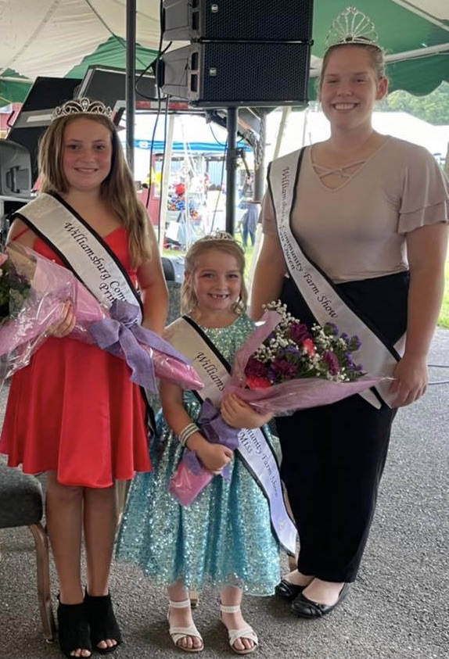

The purpose of this contest is to promote Agricultural Fairs and to create better relations between youth and adults in both rural and urban settings.

Contestants Must:
- Have exhibited at the Williamsburg Community Farm Show (this may be the first year they exhibit something, this may include art, photography, livestock, or anything else that the Farm Show has to offer)
- Be 7-10 years of age on June 1, 2022
- Have parent/guardian consent
- Sign a Code of Conduct agreement
- Attend Fair events
- Must be available for miscellaneous duties at the Farm Show even if not chosen as little miss
- Attend community organization events to promote the Williamsburg Community Farm Show
- Not hold any other title for another commodity group or pageant
- Be of good moral character

Components of Contest:
Biographical Information
Poem- “Why I Like My Fair”
Introduction
Personal Interview (5 minutes)
Impromptu Question

Biographical Information
*Can be typed or written in BLACK or BLUE ink – Use additional paper if needed*
Contestant Name:
Parent/Guardian Name:
Address:
Phone Number: Age: DOB:
School:

Answer the Following with a brief explanation:
What other activities are you involved in?

What do you want to be when you grow up?

What have been your community, church, etc. activities?

What are your hobbies?

What is your favorite part of the Williamsburg Community Farm Show?

Is there any other information you feel is important? If so, list.

Checklist for Princess Candidates
Please return the following items to be eligible for the Williamsburg Community Farm Show Princess Contest, by the deadline Saturday, July 9, 2022.

- Biographical Information Sheet
- Poem (50 words or less) “Why I Like My Fair”, Parents may help in creation of poem
- A headshot photo for publicity purposes

All information listed above must be submitted/postmarked by Saturday, July 9, 2022. Submit materials to:

Macy Walason
6528 Cortland Road
Alum Bank, PA 15521

OR by email

mwalason81@gmail.com

If you have any questions please contact Macy Walason at 814-505-7646 or by email mwalason81@gmail.com.

