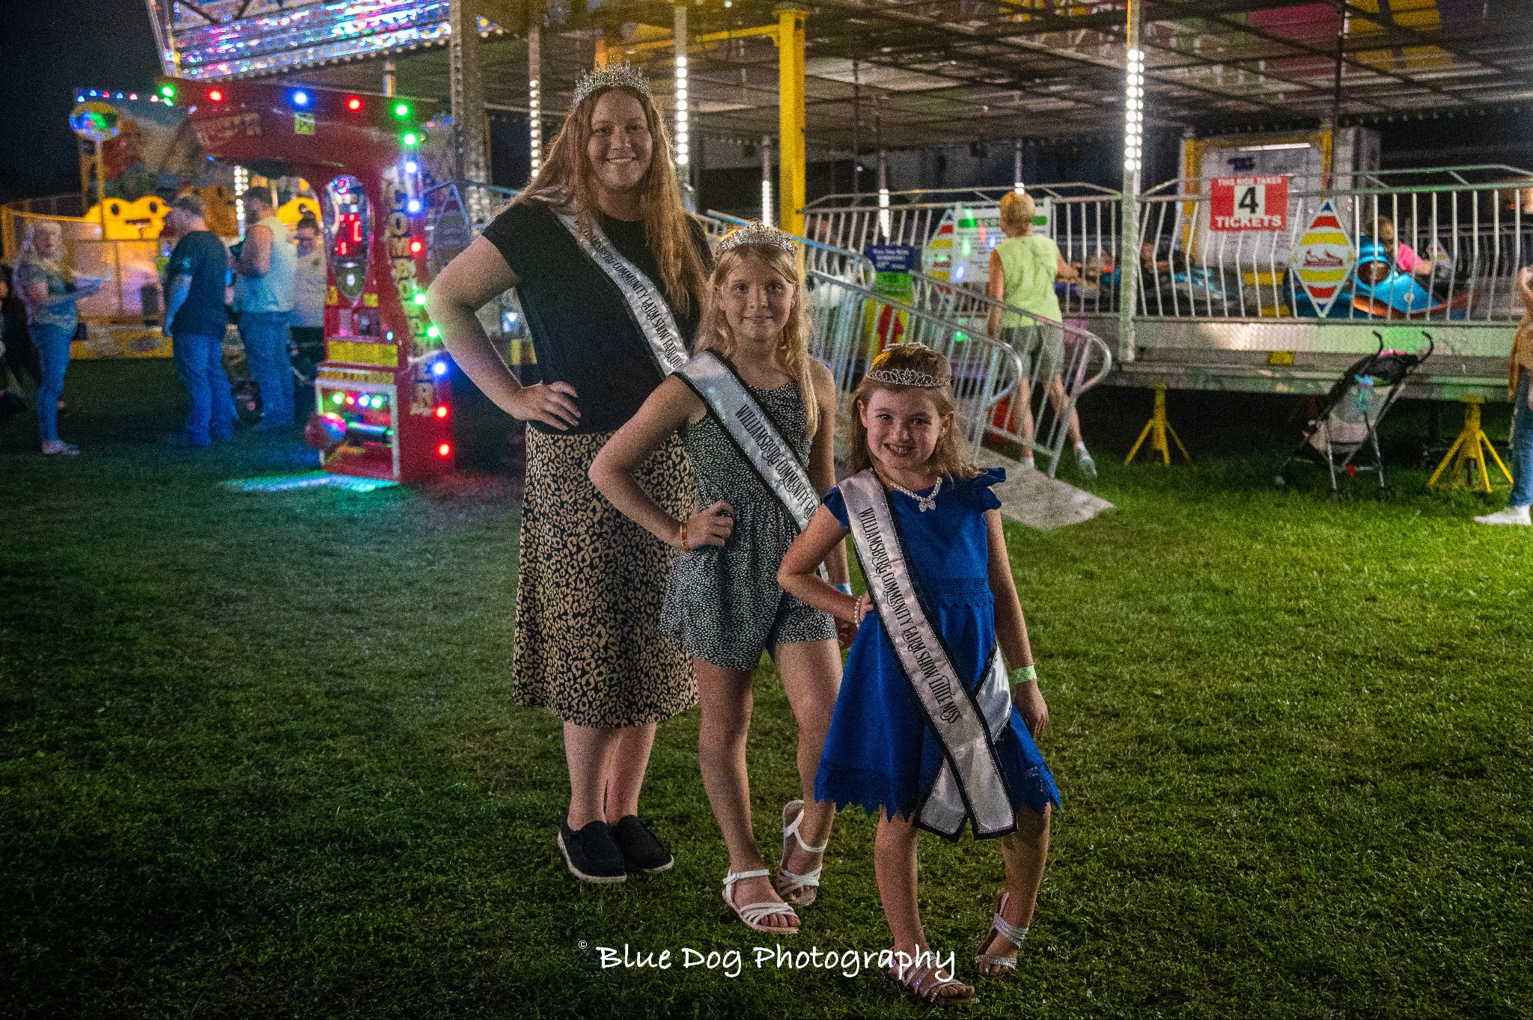

The purpose of the Fair Princess contest is to promote agricultural fairs and to create better relations between youth and adults in both rural and urban settings.

Contestants Must:
- Have exhibited at the Williamsburg Community Farm Show (this may be the first year they exhibit something, this may include art, photography, livestock, or anything else that the Farm Show has to offer)
- Be 11-15 years of age on June 1, 2024
- Have parent/guardian consent to participate
- Sign a Code of Conduct agreement
- Be available the week of the farm show August 18-24, 2024 for miscellaneous fair activities.
- Must be available for miscellaneous duties at the Farm Show even if not chosen as princess
- Attend community organization events to promote the Williamsburg Community Farm Show
- It is at the discretion of fair board and queen coordinators regarding the holding of multiple crowns/titles during their time as Williamsburg Farm Show Royalty
- Be of good moral character

Components of Contest:
- Biographical Information
- Personal Interview
- Introduction
- Brief Speech- “What is the Importance of County Fairs in Pennsylvania” 2-4 minutes timed.
- Impromptu Question

Biographical Information
*Can be typed or written in BLACK or BLUE ink – Use additional paper if needed*

Contestant Name:
Parent/Guardian name:
Address:
Phone Number: Age: DOB:
School: Grade:

Answer the Following with a brief explanation:
- What are your primary scholastic achievements?

- What awards or honors have you received?

- What is your involvement with the local community (church school FFA ect)?

- What are your hobbies?

- What is your favorite part of the Williamsburg Community Farm Show?

- Who is your role model or person who has influenced you most? Why?

- Is there any other information you feel is important? Please List below.

Checklist for Princess Candidates
Please return the following items to be eligible for the Williamsburg Community Farm Show Princess Contest, by the deadline Thursday, August 1, 2024.

- Biographical Information Sheet
- A headshot photo for publicity purposes

All information listed above must be submitted/postmarked by Thursday, August 1, 2024. Submit materials to:

Williamsburg Community Farm Show
P.O. Box 117
Williamsburg, PA 16693

OR by email

williamsburgfarmshowroyalty@gmail.com

If you have any questions please contact williamsburgfarmshow@gmail.com

