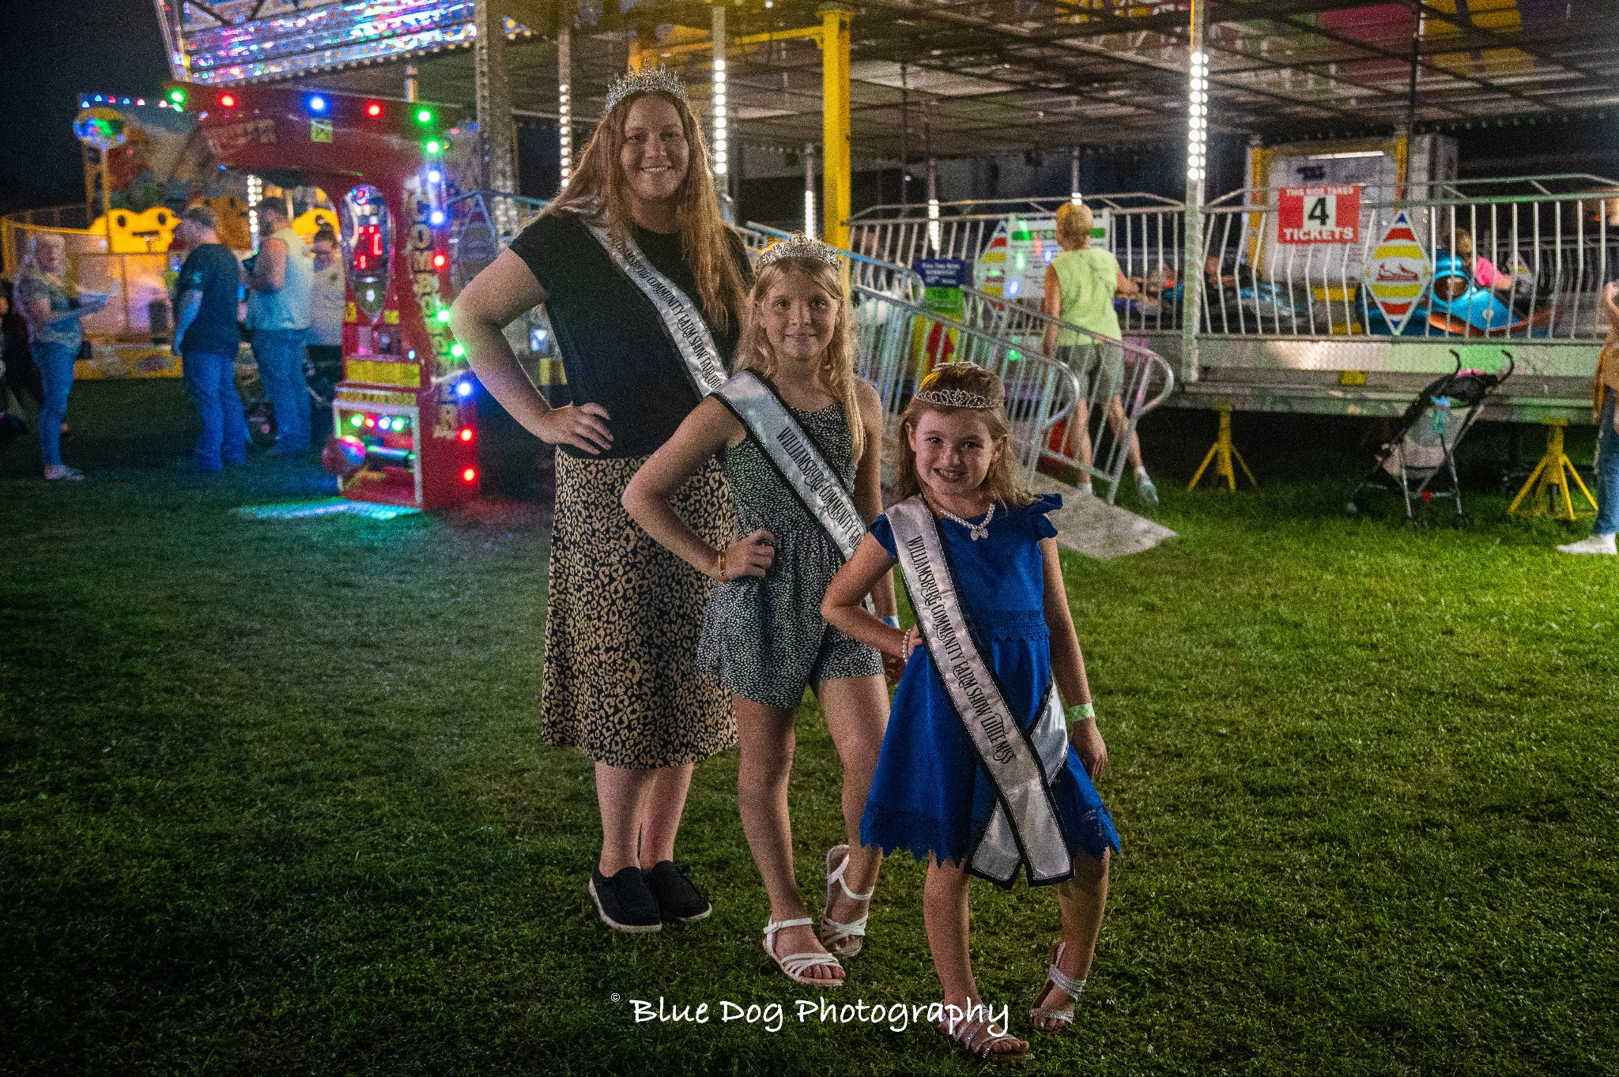

The purpose of the Little Miss contest is to promote Agricultural Fairs and to create better relations between youth and adults in both rural and urban settings.

Contestants Must:
- Have exhibited at the Williamsburg Community Farm Show (this may be the first year they exhibit something, this may include art, photography, livestock, or anything else that the Farm Show has to offer)
- Be 7-10 years of age on June 1, 2024
- Have parent/guardian consent to participate
- Sign a Code of Conduct agreement
- Be available the week of the farm show August 18-24, 2024 for miscellaneous fair activities.
- Must be available for miscellaneous duties at the Farm Show even if not chosen as little miss
- Attend community organization events to promote the Williamsburg Community Farm Show
- It is at the discretion of the fair board and queen coordinators regarding the holding of multiple crowns/title during their time as Williamsburg Farm Show Royalty.
- Be of good moral character

Components of Contest:
- Biographical Information
- Introduction
- Personal Interview (5 minutes)
- Impromptu Question

Biographical Information
*Can be typed or written in BLACK or BLUE ink – Use additional paper if needed*

Contestant Name:
Parent/Guardian Name:
Address:
Phone Number: Age: DOB:
School: Grade:

Answer the Following with a brief explanation:
- What activities are you involved in at school?

- What do you want to be when you grow up?

- What activities are you involved in outside of school (church community ect)?

- What are your hobbies?

- What is your favorite part of the Williamsburg Community Farm Show?

- Is there any other information you feel is important? Please list below.

Checklist for Little Miss Candidates
Please return the following items to be eligible for the Williamsburg Community Farm Show Little Miss Contest, by the deadline Thursday, August 1, 2024.

- Biographical Information Sheet
- Poem (50 words or less) “Why I Like My Fair”, Parents may help in creation of poem
- A headshot photo for publicity purposes

All information listed above must be submitted/postmarked by Thursday, August 1, 2024. Submit materials to:

Williamsburg Community Farm Show
P.O. Box 117
Williamsburg, PA 16639

OR by email

williamsburgfarmshowroyalty@gmail.com

Please send all questions regarding the farm show royalty competition to williamsburgfarmshowroyalty@gmail.com

