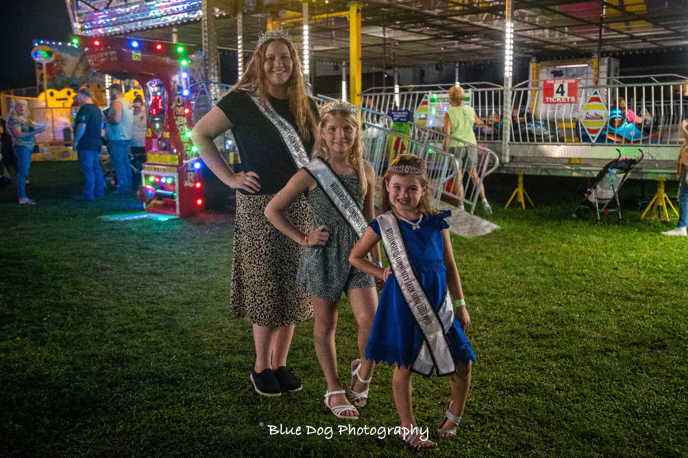

The purpose of the Fair Queen contest is to promote agricultural fairs and to create better relations between youth and adults in both rural and urban settings.

Contestants Must:
- Be a female who is a U.S Citizen and a resident of Pennsylvania.
- Have exhibited at the Williamsburg Community Farm Show (this may be the first year they exhibit something, this may include art, photography, livestock, or anything else that the Farm Show has to offer)
- Be 16-20 years of age on June 1, 2024
- Have parent/guardian consent to participate
- Be single, have never been married have not given birth to a child.
- Sign a Code of Conduct agreement
- Be available the week of the farm show August 18-24, 2024 for miscellaneous fair activities.
- Must be available for miscellaneous duties at the farm show even if not chosen as queen
- Attend community events to promote the Williamsburg Community Farm Show
- Attend the PA State Fair Convention, January 2025, in Hershey, PA if chosen as the Queen
- Contestants may not be a previous Fair Queen or have been former PA State Fair Queen contestants.
- It is at the discretion of the fair board and Queen coordinators regarding a queen holding multiple crowns or titles during the time as Williamsburg Farm Show Royalty.
- Be of good moral character

Components of Contest:
- Biographical Information
- Brief Essay- “What My Fair Means to My Community”
- Personal Interview
- Introduction
- Brief Speech- “Why You Should Come to My Fair”
- Impromptu Question

Biographical Information
*Can be typed or written in BLACK or BLUE ink – Use additional paper if needed*

Contestant Name:
Parent/Guardian name:
Address:
Phone Number: Age: DOB:
High School: Year of Graduation:
College: Major:

Answer the Following with a brief explanation:
- What are your career goals?

- What have been your primary scholastic achievements?

- What awards or honors have you received?

- What is your involvement with the local community(church, school, FFA ect)?

- What are your hobbies?

- Do you have any employment experience? Please list below.

- Is there any other information you feel is important? Please list below

Checklist for Queen Candidates
Please return the following items to be eligible for the Williamsburg Community Farm Show Fair Queen Contest by the deadline Thursday, August 1, 2024.

- Biographical Information Sheet
- Essay (300 words or less) “What My Fair Means to My Community”
- A headshot photo for publicity purposes

All information listed above must be submitted/postmarked by deadline Thursday, August 1, 2024.

Submit materials to:

Williamsburg Community Farm Show
P.O Box 117
Williamsburg, PA 16693

OR by email

williamsburgfarmshowroyalty@gmail.com

If you have any questions please contact the Williamsburg Community Farm Show Royalty Coordinators at williamsburgfarmshowroyalty@gmail.com .

